

|  |
| --- |
|  |

|  |  |
| --- | --- |
|  | SLIIT Academy Logo Final Colour  **ASSIGNMENT TOP SHEET**  **Higher Diploma in Information Technology** |

|  |  |  |  |
| --- | --- | --- | --- |
| Student Registration Number | Student Name | | |
| **SA21098796** | **S. K. K. Jayathilaka** | | |
| Lab Group | PC number | | |
|  | NA | | |
|  |  | | |
| Module Title :  **Web Application Development** | | | Module Code:  **WAD@2023** |
| Lecturer in charge :  **Mr. Madhawa Herath** | | | |
| Assignment Title :  **Project Proposal-2023** | | | |
| Due Date:  **2023 March 30** | | Date Submitted:  **2023 March** **26** | |
| Please Tick here if you have used a proof-reader for this assessment : | | | |
| Turnitin Paper ID* | | | |

*Not required if not submitting via Turnitin

|  |  |
| --- | --- |
| **Declaration** | |
| I declare that work presented in the assignment submitted to the Sri Lanka Institute of Information Technology is a record of an original work done by myself*.* This assessment is submitted in the partial fulfilment of the requirement for the award of the degree of Bachelor of Science in Information Technology. The results embodied in this report have not been submitted to any other University or Institution for the award of any degree or diploma. Information derived from the published or unpublished work of others has been acknowledged in the text and a list of references is given. | |
| *Name(s) and Signature(s) :*    **S. K. K. Jayathilaka** | *Date:*  **2023 March 30** |

**Extension Deadline**

Lecturer in charge agrees that the assignment may be submitted ……………. days after the deadline and should be marked without penalty.

Lecturer in charge confirmation: ………………………………………………………………………………..

**CONTENT**

1. Introduction
   1. **Problem Specification**
   2. **Solution Outline**
   3. **Key Benefits**
2. Functionalities
3. Conclusion

**Introduction**

Electronic Commerce or e-commerce is business transactions that take place by communication networks. It is a process of buying and selling products, services, and information over computer network.

Absence of a proper Web design seems to be a huge setback for a blooming and even for an established business.

* The scope of this project is to design and develop a professional e-commerce website for your Product products-small business **“PRODUCT CORNER”**.
* This website allows potential customers to find your business and learn about your products or services.
* You can use your website as a hub to run marketing campaigns on social media platforms or search engines.
* This website also help to level the playing field by allowing small businesses to compete in the same domain as larger businesses.
* It’s incredibly simple to use.



Electronic Commerce or e-commerce is business transactions that take place by communication

networks. It is a process of buying and selling products, services, and information over computer

network. E-commerce is a set of dynamic technologies, applications and business process that

link organizations, customers, suppliers and communities through electronic transactions and the

electronic exchange of information products and services

Electronic Commerce or e-commerce is business transactions that take place by communication

networks. It is a process of buying and selling products, services, and information over computer

network. E-commerce is a set of dynamic technologies, applications and business process that

link organizations, customers, suppliers and communities through electronic transactions and the

electronic exchange of information products and

* 1. **Problem Specification**

**By not having a website,**

By not having a website to your small business **PRODUCT CORNER**, you will be automatically losing the opportunity to get in touch with your audiences.

* A poor customer relationship:

You can convey your company updates instantly to your consumers via a website. Without a website, you can never connect to your prospective audiences.

* Poor accessibility:

Customers can have a through idea about your products, services, pricing, location, mission & vision and so on. Whatever you want them to know, they can get it just with a few random clinks of a mouse.

* What’s the better place to show all your offers?

Since it’s the time of the internet, where could be better than a website to showcase your discounts. We know that every time you go on sale, make offers, it means you want to attract more customers and lead to revenue. Without a website and digital marketing, how could you reach all your target customers?

* Not satisfying your customers’ need.:

As a customer, no one wants to constantly message a business on social media to ask for more info and prices of several products. If people see that it's an inconvenience for them, they will leave and find another business to replace.

* Missing out on organic traffic:

If you’re not showing yourself up in the net, you’re definitely missing a whole lot of organic traffic. As a small business owner, showing up on high ranks in Google Search is a dream. Not only it gives you the perfect, sweet opportunities to dramatically boost your sales, but you’ll be seen by a lot more users. As long as you have great Google ranks, even if you don’t put much investment into advertising, you can still expect good results.

* Trust and conversion from a website for small business:

After a long time working in the business industry, we figured out that the best way to boost your users’ trust is to give them your priority. Putting their experience above anything else, do anything you could to fulfill their needs. And to show that on your website, you should show that you care in every smallest detail.



* 1. **Solution Outline**

**By having a website,**

* Web Payments:

When purchasing online, Customers can select from thousands of products and services, compare and contrast easily, read reviews, make the payment seamlessly, and get your product delivered within days.

* 365 days a year accessability:

Having a website means customers are always able to find you – anytime, anywhere. Even outside of business hours, your website continues to find and secure new customers.

* Contact Info

Contact information gives users a way to get in touch with you.

* Shopping cart:

Customers can add their products to the cart and go the checkout.

* Order tracking:

This system, that allows you to monitor all your online orders and report their status to your customers at any time. This system includes estimated delivery dates, shipment tracking, and frequent updates on an order's location.

* Better Security:

Web apps offer better security to the users, which ultimately leads to gaining better customer loyalty for your business.

* Data Recovery:

You can quickly recover data in case of data loss or technical blunders using this web application.



* 1. **Key Benefits**

Websites, in general, are great ways to in providing a place that potential investors can be referred to. It shows what your company is about, what it has achieved and what it can achieve in the future.

Establishing trust, strengthening your brand, forging better customer relations, and informing a wider group of people about your business’s capabilities are all key benefits.

* Information Exchange:

This website provides a quick and easy way of communicating information between buyers and sellers.

* Market Expansion:

As your site is accessible to anyone all over the world, the ability to break through geographical barriers has never been easier. Anyone, from any country, will be able to find your company and as such, is now a potential customer.

* Share the latest news:

Sites that have fresh, relevant and timely information draw users back more often.

* Customer Service Online:

Websites provide an easier way to handle customer service. Offering answers to regularly asked questions in a FAQ (Frequently Asked Questions) section, you can reduce customer service costs and save yourself time and money, as well as providing much more information. This also means that customers can receive a reply instantly and saves time, which helps to encourage positive customer relations in the long run.



**Functionalities**

**WEB APPLICATION ARCHITECTURE**

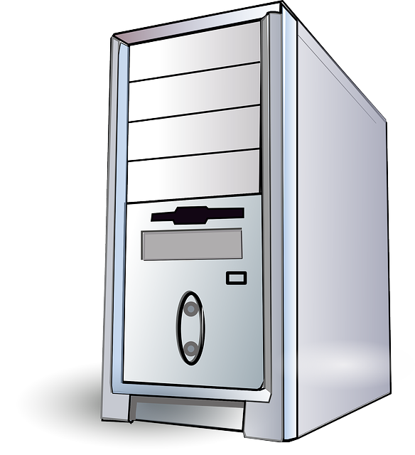





Collect Data

**Products/Prices/Customer info/Employee info stores in here**

PHP, JavaScript, Java

Web Server

Receive Data

Request Data



Receive Registration or ordered details

User Login to our website and interacts with HTML, JavaScript, CSS

**FRONTEND**

**USER**





**Data Base**

MYSQL

**BACKEND**

**File System**

HTML, CSS

To develop this web application, we will use the following technologies and Programming languages

1. **Front – End user interface: HTML, CSS and JavaScript**

* **Domain Name:** The URL for your website that appears in the navigation bar. This is the address where visitors are able to find you, or the address they are taken to after search leads them to your site.
* **Company Name:** Your Company’s name **“PRODUCT CORNER”** should appear pretty high up somewhere on the homepage, reassuring visitors they’ve come to the website they were looking for. Users should not have to scroll to find your company name.
* **Search Bar:** Some users know exactly what they want from your site, and just need help navigating to that page.
* **Logo:** Logos should also appear high up on the homepage. Logos are small, easy-to-remember graphics that create a link in a customer’s brain between your company and that image.
* **CTAs:** A CTA, or call to action, can be anything from “create a login,” to “book a demo,” to “get on our mailing list.
* **Live Chat:** More and more, websites are utilizing live chat software as an opportunity to get in touch with site visitors and provide top-tier customer service.
* **Contact Info:** Contact information gives users a way to get in touch with you.

1. **Back – End: PHP**

* **Validates and exchanges information such as login IDs and passwords**: The back end code also saves any information the user submits to the databases.
* **Customizes your product for multiple environments:** Your Company can set up websites and other internet features in many environments.
* **Adds utility to front end functionality:** Programmers need to create back end code as part of the website development process to make each front end capability more useful. For instance, to make a user login form function, they must write code in a server-side programming language.
* **Improves the user experience:** The back end of a website is where all work necessary to make it work occurs. So, the quality of the back end code will affect the user experience provided by a website.

1. **Storing data: MYSQL database**

**Conclusion**

By the creation of a web-based application, this project seeks to solve the issues that the **“PRODUCT CORNER”**. store is now experiencing. The system will offer a number of advantages, including improved customer experience, accurate and effective administration of customer information, and optimization of sales and inventory management functions. To create this system, we'll use HTML, CSS, JavaScript, PHP, and MySQL.